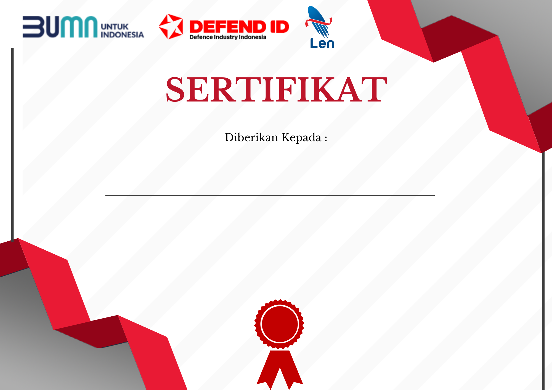

P0622/ LEN/OJK/LH-4/III/2022

**Ardhitya Rangga Saputra**

**NIS. / NIM. 19/446487/TK/49592**

Telah Melaksanakan *On The Job Training* (OJT) di :

PT Len Industri (Persero)

Dilaksanakan pada tanggal 17 Januari 2022 sampai 04 Maret 2022

*Dengan Predikat Nilai*

A

Bandung, 04 Maret 2022

Perusahaan Perseroan (Persero)

PT Len Industri

Alvin Anindya Sapi’ie., S.T., M.B.A.

GM Human Capital Operation &

industrial Relation

|  |  |  |  |  |  |
| --- | --- | --- | --- | --- | --- |
| **LEMBAR PENILAIAN PESERTA** | | | | | |
| ***On The Job Training* (OJT)** | | | | | |
| **Nama** | **:** | **Ardhitya Rangga Saputra** | **Kompetensi Keahlian / Program Studi** | **:** | **Teknik Elektro** |
| **NIS. / NIM.** | **:** | **19/446487/TK/49592** | **Unit Kerja Penempatan** | **:** | **System Engineering Division** |
| **Asal Instansi Pendidikan** | **:** | **Universitas Gadjah Mada** | **Pembimbing Industri** | **:** | **Wisnu Adji Kharisma, S.T.** |

|  |  |  |
| --- | --- | --- |
| **Indikator Nilai** | **Nilai** | **Predikat** |
| 1. **Pengetahuan** |  |  |
| Penugasan / Pengetahuan Bidang Kerja | **95** | **A** |
| Kemampuan Memecahkan Masalah | **95** | **A** |
| 1. **Keterampilan** |  |  |
| Keterampilan Teknis | **94** | **A** |
| Kualitas / Mutu Hasil Kerja | **93** | **A** |
| Ketepatan Waktu Penyelesaian Pekerjaan | **95** | **A** |
| 1. **Sikap** |  |  |
| Kejujuran | **95** | **A** |
| Kedisiplinan | **95** | **A** |
| Tanggungjawab | **95** | **A** |
| Motivasi | **95** | **A** |
| Inisiatif | **93** | **A** |
| Kerjasama Tim | **100** | **A** |
| Interaksi Sosial | **97** | **A** |
| **Rata-Rata** | **95,1** | |
| **Jumlah** | **1142** | **A** |

|  |  |
| --- | --- |
| **Range**  **Nilai** | **Kriteria** |
| **91 - 100** | **A (Sangat Baik)** |
| **81 - 90** | **B (Baik)** |
| **71 - 80** | **C (Cukup)** |
| **61 – 70** | **D (Kurang)** |
| **0 - 60** | **E (Sangat Kurang)** |

